Journal Name: Tree Physiology

Manuscript type: Research paper

**Low risk of damage from short duration spring freeze events in three foundational North American tree species**

Joe Endris1 and Evan Rehm1&2

1 Biology Department, Austin Peay State University, Clarksville, TN 37044 United States

2Northern Research Station, US Forest Service, Morgantown, WV 26505 United States

*Corresponding author

Joe Endris: [endrisj@outlook.com](mailto:endrisj@outlook.com)

Biology Department

Austin Peay State University

Clarksville TN

931-221-7781

Key words

bud burst; freeze resistance; freezing tolerance; frost; spring leaf-out

**Abstract**

Spring phenology plays a significant role in temperate forest ecosystems by signaling the end of winter dormancy and the start of the growing season. The timing of dormancy release means balancing the benefit of early photosynthesis with the risk of damage to sensitive newly forming tissues to late spring freezing temperatures. However, the thermal tolerance of native North American trees is chronically understudied, particularly in the face of changing winter and spring temperatures. We conducted phenological observations and freeze tolerance assessments over two springs to determine the thermal safety margins for three foundational species of hardwood trees common to eastern North America: *Acer saccharum*, *Fagus grandifolia*, and *Liriodendron tulipifera*. Using historical temperature records spanning from 1980 to 2023, we show that late winter and spring at our study site has a gradual warming trend, fewer freezing days, and an advancement of the last freeze date. However, cold temperature extremes have not changed despite overall warming during this period. All three species displayed phenological advancement in an abnormally warm spring (2023) compared to an historically average year (2022). Despite strong differences in phenology, we show that all three species exhibit significant thermal safety margins compared to the spring temperatures during the respective study years in addition to historic low temperatures. The findings underscore the nuanced relationship between phenology and freezing tolerance, suggesting low risk of damage from short-term spring freezing events despite advanced phenology.**Introduction**

Change text to reflect point from reviewer 1: The authors might consider a slightly different framing where, regardless of climate change projections, frost risk to and tolerance of temperate trees is an important topic. This might mean just briefly mentioning climate change and how risks may increase or stay constant into the future.

We will need to strike a balance of providing some background on controls of spring phenology while not going into too much detail. We should include text that explains that winter temperature impacts on spring phenology timing are complicated BUT what we are doing here is trying to show 1)how LT50 varies across species and from year to year and 2) how close these LT50s get to true cold temperatures in two very different spring temperature years.

The timing of bud break in temperate forest trees is a balancing act between maximizing carbon gains by starting photosynthesis while minimizing the risk of exposing newly formed tissues to late spring freezing temperatures (Lenz et al. 2016, Geng et al. 2020). Initiating leaf-out early can lead to an extended growing season and reduced competition for sunlight before canopy closure. However, early phenology comes at a risk of late spring freeze damage (Sakai and Larcher 1987, Augspurger 2013) due to photosynthetically active tissues being sensitive to sub-zero temperatures (Vitra et al. 2017).

Since newly forming leaf tissues are at risk during the leaf-out process, warmer temperatures through winter and during the winter to spring transition, can impact the timing of leaf-out. This can present a significant impact on tissue survival and health (Richardson et al. 2018, Baumgarten et al. 2023). Advances in leaf phenology in response to warming mean temperatures are widespread and well documented across broad geographic regions and plant types (Morin et al. 2009, Polgar et al. 2014, Geng et al. 2020, Büntgen et al. 2022, Chen 2022, Vitasse et al. 2022). Last freeze date and cold temperature extremes are variable, potentially creating increased risk levels for emergent leaf tissues to freezing temperatures during spring (Zohner et al. 2020, Chamberlain and Wolkovich 2021). These discordant changes in temperatures in late winter and early spring temperatures that lead to shifts in phenology are altering the risk of tissue damage by causing a disjunction between spring phenology and spring freeze timing.

The importance of the timing of phenology and late spring freezing events is highlighted when phenology advances in response to mild spring temperatures but is followed by late spring freezing temperatures that can damage newly forming tissues (Chamberlain et al. 2019). In 2007 much of the eastern United States experienced abnormally warm temperatures in March that advanced spring leaf-out by several weeks. This warm spell was followed by a sustained record low temperature event in April that resulted in widespread leaf-damage across much of the south and mid-south US (Gu et al. 2008, Augspurger 2009). In Tennessee and Illinois, canopy development was effectively reset after the freeze with leaves dying and trees having to flush a new set after the freeze event (Gu et al. 2008, Augspurger 2009). In addition to the initial loss of leaf biomass after the freeze, much of the impacted forest never recovered to normal foliage density for the remainder of that growing season (Polgar and Primack 2011). Following similar freezing events in Europe, oak and beech trees can require up to two years to return to growth levels prior to a spring freeze (Vitasse et al. 2019). Therefore, such late spring freeze events may be becoming more relevant to forest dynamics and growth as winter and spring temperatures change under climate warming.

Despite such late spring freeze events causing widespread disruptions to forest canopy development, we still have a poor understanding of species-specific freezing tolerances during this spring transition, with most studies focusing on extreme freezing temperatures during the mid-winter period (Chuine and Beaubien 2001, Kreyling et al. 2015). Those studies that do focus on spring freezing tolerance have heavily focused on cultivated species for horticultural or agricultural uses (Eccel et al. 2009, Geange et al. 2021, Yang et al. 2021). Research on wild woody plants has largely been conducted on species common to Europe, and even then, most studies have focused on one or two dominant species (e.g. Fagus sylvatica; Vitasse 2013, Lenz et al. 2013, 2016, Vitasse et al. 2019). This has left large gaps in our knowledge regarding temperate North American forest species (Geange et al. 2021) and hinders forest modeling under future climates.

Potential mismatches between spring phenology and freezing risk could lead to differential success among forest species, ultimately altering community composition. For example, a mix of woody and herbaceous species that do not shift spring flowering timing with temperature have declined in abundance in Massachusetts (Willis et al. 2008). Therefore, to accurately predict the threats to forest species from climate change, we must first understand the risks associated with the shift in phenology in concert with damage associated with late spring freezing events. Our goals in this study were to (1) compare freezing tolerance for three wide-spread and foundational species of eastern North American hardwood forests during spring leaf-out (late winter through late spring), (2) relate freezing tolerance throughout the spring to contemporary and historical spring freeze events to determine thermal safety margins and (3) determine interannual variation in spring freezing risk over sequential years with drastically different spring temperature patterns.

**Methods**

Study site

This study took place at the Austin Peay State University Farm and Environmental Education Center located in Clarksville, Tennessee, USA (36.5701°, -87.3385°, 145-155 m asl). The site consists of approximately 80 ha of 60-year-old second growth forest, with dominant species of *Fagus grandifolia, Acer spp,* and *Quercus spp*. We used data retrieved from a station XX km from the study site and positioned in a similar forest type and aspect from the National Oceanic and Atmospheric Climate Data Online (National Oceanic and Atmospheric Administration 2023, www.ncei.noaa.gov/cdo-web, station ID USC00401790).

We selected three deciduous tree species that are foundational in secondary forests throughout much of the eastern United States: *Acer saccharum* Marshall, *Fagus grandifolia* Ehrh., and *Liriodendron tulipifera* L. Additionally, these species vary in timing of their spring phenology with *L. tulipifera* generally displaying an earlier leaf out compared to *A. saccharum* and *F. grandifolia*. All individuals of the same species were selected based on proximity (all individuals collected from within 50 m of each other), were on north-facing aspects, at the same elevation, relatively flat terrain, and in similar levels of canopy cover to reduce the effects of microclimate on interspecific freezing tolerance variation. Trees were 8-75 cm in diameter at breast height and were all approximately 20-60 years old.

Phenology

We conducted phenological observations on the study species throughout the winter to spring transition (defined here as February to May in temperate eastern North America) during 2022 and 2023. For each species we selected five individuals that were different than those selected for freezing tolerance (see below) to avoid any compounding effects that bud removal may have on tree phenology. We ranked bud development on a scale between zero and four (following Vitasse et al. 2014), with zero indicating no bud activity, one indicating bud swelling, two indicating bud burst, three indicating initial, immature leaf formation, and four indicating full leaf development. We began observations on 15 February 2022 and 10 February 2023 to ensure observations occurred prior to any visual bud development. We conducted the observations on a biweekly basis and continued until all individuals had developed full leaves for the year. Observations concluded on 3 May 2022 and on 20 April 2023.

Freezing tolerance

We sampled six individuals for each target species for freezing tolerance during the spring of 2022 and 2023. Sampling began in mid-February and continued until the first week of May with samples collected on a biweekly basis. From each tree, we collected either six buds or, later in the season, leaves at each collection date. The sampling occurred between 10:00 am and 12:00 pm and tissues were immediately placed into polyethylene bags to minimize water loss. We stored the samples overnight in a walk-in cooler set at 4°C.

The day following collection, we randomly assigned each bud/leaf tissue from an individual to one of six treatment temperatures: 4°, -2°, -5°, -8°, -11°, and -40°C. We placed the tissues into brown paper bags and bundled all tissues assigned to the same temperature. Tissues assigned to the treatments between -2° and -11°C were placed into a reach-in freezer (Darwin Chambers model TH030-AA; St. Louis, Missouri, USA) that was pre-cooled to 4°C. The temperature in the chamber was then reduced at a rate of 4°C per hour until the first target temperature of -2°C was reached. The treatment temperature was maintained for one hour, after which the tissues for that treatment temperature were removed from the freezer and placed into a resealable polyethylene bag. We then returned the tissues to the 4°C walk-in cooler and allowed them to thaw at a rate comparable to the freezing rate (2-5°C per hour). After we removed the target temperature samples, the cooling to the next treatment temperature began and we repeated this sequence for all treatment temperatures.

The 4° and -40°C samples serve as a live and dead control respectively. The 4°C samples were placed into a polyethylene bag and placed into the walk-in cooler maintained at 4°C, while the -40°C samples were placed into a -40°C freezer (So-Low model number C85-14; Cincinnati, Ohio, USA) for 24 h. The -40°C exceeds the record low temperature of -28.9°C (NOAA 2023) since 1980 for the study area.

After the samples were thawed in the walk-in cooler overnight, we evaluated tissues on a subjective basis by conducting a visual inspection to determine the percentage of dead tissue. Dead tissue for all species appears brown (Figure S1 and Figure S2) and/or limp to the touch. To assess damage with a more quantitative measure we followed the electrolyte leakage methods outlined by Lim et al. (1998). Tissues were placed into individual test tubes with 15 mL of deionized water and returned to the walk-in cooler for 24 h. An initial electrolyte measurement was then taken using a conductivity meter (Traceable model number 15-077-977; Hampton, New Hampshire, USA). Samples were next placed into an autoclave (Steris model number SG-120; Mentor, Ohio, USA.), to kill all bud/leaf tissues. The samples were then left for 72 h to allow for further electrolyte leaching and after 72 h, a second electrolyte measurement was conducted in the same manner as the initial.

Data analysis

We conducted our analyses in R 4.3.0 (“The R Project for Statistical Computing” 2023) and used an alpha-value of 0.05 to designate significance. We looked at temperature means and extremes between 1980 and 2023 in a variety of ways using data retrieved from NOAA CDO. To investigate change at a coarse scale, we determined if daily low temperature during late winter through the spring (defined as 1 February - 30 April) was dependent on Julian Date and year (1980-2023) using multiple linear regression. We established the cut off at 30 April as the record latest spring freeze since 1980 is 24 April 1983. To gain a better understanding of how temperatures have warmed through the core leaf-out window, we conducted the same analysis but this time using daily low temperature for February, March, and April separately as dependent on Julian date and year. Finally, we used a linear model to determine any changes in the Julian date of the last freeze (defined here as temperature below -2°C) or the absolute coldest temperatures for each year from 1980-2023.

In addition to temperature, we also compared phenological development (categorized as 0-4) in 2022 and 2023. We used a generalized linear model to determine if differences in phenological development varied between fixed effects of species, Julian date, and years.

We used the lethal temperature where 50% (LT50) of leaf tissues were damaged to determine freezing tolerance (Sakai and Larcher 1987, Murray et al. 1989). We determined the LT50 value for each individual tree for each species using nonlinear Gompertz models (following Lim et al. 1998 and Lenz et al. 2013) in R using the nlsLM function from minpack.lm package (Elzhov et al. 2010). We then investigated temporal and interspecific variation in LT50 values by modeling LT50 by species, Julian date, and year and all two-way interactions using a generalized linear model. We performed model selection using an all subsets approach to determine the most parsimonious model following Burnham and Anderson (2002). Models were considered competing when they were within two Akaike Information Criterion units of the lowest ranked model. When there were competing models, the simplest model was chosen and a posthoc Tukey Honestly Significant Differences test for pairwise differences was used if species was included in the model.

**Results**

Minimum temperatures

Overall winter and spring temperature data show a gradual warming trend since 1980 at our study site but with absolute low temperatures not changing. We found that the mean low temperatures have been warming through the leaf-out period with February, March, and April warming on average of 0.05° to 0.08C per year for a total of roughly 2.2-3.5°C increase (p<0.001). The daily low temperature has warmed since 1980 (p<0.008), but the record low temperature for each year has not significantly increased since 1980 (p=0.243). Since 1980, the study site has seen fewer days with a low temperature below -2°C in the first four months of the year (Figure 1, p<0.0001, R2 = 0.343, slope = 0.525). Additionally, the Julian date for the last freeze event has advanced since 1980 (p=0.03, R2=0.09, slope= -0.388). Collectively, mean low temperatures have increased at our site and freezing events have become less common but low temperature extremes have stayed largely constant since 1980. Against the backdrop of long-term temperature changes, the leaf-out period (defined as February to April) in 2022 and 2023 highlight strong interannual variation in winter and spring temperatures. In 2022 there were 41 days below -2°C, with 2023 having only 17 days that reached the same temperature threshold. However, the last freeze in 2022 was on 20 April, much later than the long-term mean of 24 March, while 2023 was slightly earlier than the long-term mean on 19 March.

Phenology

The best model to describe differences in phenology included Julian date and year (Table 1). We found that phenology significantly advanced with Julian date (p<0.001) and that plants exited dormancy earlier in 2023 than in 2022 (p<0.001). Species did not feature in the best model for phenology despite *L.* *tulipifera* having earlier bud development than *A. saccharum* in both years. In 2022 buds for *A. saccharum* began showing signs of activity on 7 April and on 24 March in 2023 (Figure 2). For *F. grandifolia* activity in 2022 began on 15 March and in 2023 on 2 March, with *L. tulipifera* signs of activity observed in 2022 on 7 April and in 2023 on 2 March. Notably, the National Phenological Network reported that in the southeastern United States, spring in 2023 was approximately 20 days ahead of 30-year leaf index dates (1991-2020, USA National Phenology Network 2023) in and around our study site. In comparison, the spring in 2022 was in-line or behind the 30-year index for the southeastern United States.

Freezing tolerance

The best model for freezing tolerance, here defined as LT50, included Julian date and species but did not include year, despite tissue activity being significantly advanced in 2023 relative to 2022. We found that freezing tolerance decreased (i.e. LT50 values became less negative) as Julian date increased (Table 2; p<0.001). Additionally, we found that *A. saccharum* had lower LT50 values than *F.* *grandifolia* (p=0.003, Tukey HSD test, Table 3) and *L.* *tulipifera* (p=0.024), but no difference was found between *F.* *grandifolia* and *L.* *tulipifera* (p=0.778).

For each year, all three study species maintained thermal safety margins of approximately 10-12°C below air temperatures throughout the leaf-out periods. When compared to historical low temperatures since 1980, species thermal safety margins were still approximately 5-8°C below historical minima, with the exception of the first two sampling intervals, when calculated LT50 values were in-line with 35-year minimum temperatures. Despite 2023 being an extremely warm winter and spring with plants having advanced phenology, the LT50 values were still well below the historical extremes.

**Discussion**

Warming winters and springs have advanced phenological timing of many plant species globally (Geng et al. 2020, Chamberlain et al. 2021). This phenological advancement can lead to late spring freezing temperatures damaging newly formed leaf tissue, especially in warm years. Indeed, such late spring freeze events have resulted in widespread canopy damage across diverse geographic regions (Augspurger 2009, Bascietto et al. 2018, Askeyev et al. 2022). Therefore, the timing of spring phenology and spring freezing temperatures can combine to impact freezing risk in trees. We show here that three foundational eastern North American trees maintain high freezing tolerances and can likely withstand short-term cold temperature events in the spring at this study site. This large thermal safety margin between bud and leaf freezing tolerance and freezing temperatures is maintained even when leaf phenology is significantly advanced in warm years. These data show that some species may be able to expand their growing season to earlier in the spring while still having low risk of leaf damage to freezing temperatures.

Winter and spring temperatures play an important role in leaf phenology and freezing risk in temperate forests. We found that at our site, several measures of freezing temperature and freeze risk have been ameliorated by warming temperatures in recent decades. Since 1980, the number of late winter and spring days (January to April) with freezing temperatures have decreased and extreme low temperatures have increased (i.e. became less negative). These temperature data match broad-scale warming patterns that show an advancement in the last spring freeze date in North America, leading to reduced risk associated with late spring freezes (Park et al. 2020, Zohner et al. 2020). Conversely, when taken into account the expansion of the growing season due to earlier phenology, the number of growing season days with exposure to freezing temperatures has increased in central North America and some other geographic regions over the last 35 years (Liu et al. 2018). These contrasting findings highlight that any consideration of spring-time temperature impacts on leaf tissues must consider leaf phenology simultaneously.

While our data showed no interspecific differences in phenology, we do show interannual variation that seems dependent on temperature. It is important to note that our study only covers two years, and that 2022 had average temperatures for spring and 2023 was exceptionally warm. The warmer temperatures in 2023 led to an advance in phenology with all three species breaking buds two to three weeks earlier when compared to 2022. This year-to-year variation is in-line with a broader survey of 173 woody species from the Northern Hemisphere that showed the majority responded more strongly to spring temperature cues than photoperiod to drive leaf out (Zohner et al. 2016). With continued advancement of phenology in response to warming temperatures, tissues may become active earlier in the spring, leading to increased risk of freezing temperature exposure.

While phenological advancement is well documented and widespread, it is not occurring at the same rate around the globe (Zohner et al. 2020, Xiong et al. 2023), leading to spatially variable risks for species and populations. For example, the largest factor associated with risk of late spring freeze damage for a variety of European trees was advancing phenology (Vitasse et al. 2014). Since European species have advanced their phenology nearly 6.5 days since 1983 (Chamberlain et al. 2021), these species may have a heightened risk of exposure to late spring freeze events under warming temperatures. Conversely, a study of herbarium specimens from North America found that flower damage due to spring freezing temperatures has decreased since the early 1900s because the last freeze date has advanced faster than phenology for most studied angiosperms (Park et al. 2020). Despite the documented importance that advancing phenology plays in determining freezing risk, our data suggest that high freezing tolerances leading to large thermal safety margins may offset increased risk associated with bud break earlier in the year. Therefore, understanding freezing tolerance thresholds is as important as phenology timing when assessing spring freezing risk.

The importance of this interaction between phenology and freezing tolerance is well documented in European trees where species-specific freezing tolerance and phenological timing are both important in determining species risk to late spring freeze damage (Vitasse et al. 2014, Lenz et al. 2016). Despite our phenological data not showing any interspecific differences in leaf timing, *A. saccharum* leaf emergence occurs two to three weeks later than the other two study species. This lack of statistical difference in species phenological timing may be due to our relatively small sample size but true ecologically meaningful differences do exist. For example, we found interspecific differences in freezing tolerance that may indicate variable risk of freezing damage during rare, extreme cold events.

If long-term cold temperature records for a given Julian date are used as a proxy for temperatures that an individual needs to withstand, then we see a striking pattern of some species with little freezing risk, no matter the year. Since 1980, our study site has had a mean last freeze date of Julian day 83 with the record low temperature for that date of -9.4°C. At this Julian date in 2022, *A. saccharum* maintained a mean LT50 value of -10.8°C, *F.* *grandifolia* a value of -16.1, and *L.* *tulipifera* at -14.3°C. At this same date in 2023, *A. saccharum* maintained a mean LT50 value of -9.7°C with *F.* *grandifolia* and *L.* *tulipifera* at -15.1°C and -14.3°C respectively. This suggests that a severe freeze event may come close to harming *A. saccharum* due to this species’ narrower thermal safety margin (1.4°C in 2022 and 0.3°C in 2023) while not impacting the other two study species regardless of phenological status (thermal safety margin of other species >4.9°C in both years). While current freezing tolerance levels in all three species give one measure of potential freezing risk, variation in phenological timing and LT50 could interact to cause variable freezing risk in co-occurring species.

Both *F.* *grandifolia* and *L.* *tulipifera* displayed dormancy release by Julian day 70 in 2023. The record low temperature since 1980 for that Julian date is -8.3°C, yet the two species maintained LT50 values of -18.5°C and -15.9°C respectively despite tissues becoming physiologically active. These species have a large thermal safety margin in newly forming tissues, indicating a reduced risk to short-term freezing events. Yet *A. saccharum* released dormancy several weeks later and had a smaller thermal safety margin. If *A. saccharum* were to have released dormancy at the same time as the other two species, freezing tolerance would have been roughly in line with freezing temperature extremes. This large thermal safety margin for two of our species, even in an advanced phenological year like 2023, is surprising given that the forests in our study area were negatively impacted by a geographically widespread freezing event in April 2007 (Gu et al. 2008, Augspurger 2009). It is important to note that our research is only indicative of single-day or short-term freeze events, not multi-day events with sub-zero temperatures such as the 2007 event.

**Conclusion**

As climate change continues to exert new pressures on existing species, potential shifts to temperate forests are likely to occur. Continued shifts in phenology can impact species distributions and range shifts especially when phenology is mismatched with local climates resulting in small or no thermal safety margins during the critical leaf-out period. For this study, we focused on leaf tissues due to their importance to forest species for carbon capture. Most previous studies have similarly focused on leaves while other tissues such as flowers and fruits have largely been overlooked. Yet in many North American trees, flowers emerge prior to leaves and are similarly shifting timing in response to climate change (Inouye 2000). With limited species-level data, predicting future forest growth and carbon assimilation in climate change scenarios is difficult. While our research indicates that these three species maintain sufficient thermal safety margins during the leaf-out period, further research is needed into longer-duration freeze events, the effects of freeze events on reproductive tissues and an expansion of studies on other species throughout temperature north American forests.

**Author contribution**

ER designed the experiment. JE conducted the experiment and led the writing of the manuscript. JE and ER analyzed the data. Both authors contributed critically to the drafts and gave final approval for publication.

**Funding**

This research was financially supported by the Austin Peay State University Department of Biology Graduate Research Grant and the Society of American Foresters Mollie Beattie Visiting Scholar Program.

**Conflict of interests**

The authors have no conflicts of interest concerning this manuscript.

**Data availability**

Data and analysis code will be available on GitHub prior to publication.

**ORCID**

*Joe Endris* https://orcid.org/0000-0001-6240-9176

*Evan Rehm* https://orcid.org/0000-0002-5804-0027**References**

Askeyev, O., A. Askeyev, I. Askeyev, and T. Sparks. 2022. Extreme temperatures help in identifying thresholds in phenological responses. Global Ecology and Biogeography 31:321–331.

Augspurger, C. K. 2009. Spring 2007 warmth and frost: phenology, damage and refoliation in a temperate deciduous forest. Functional Ecology 23:1031–1039.

Augspurger, C. K. 2013. Reconstructing patterns of temperature, phenology, and frost damage over 124 years: Spring damage risk is increasing. Ecology 94:41–50.

Bascietto, M., S. Bajocco, F. Mazzenga, and G. Matteucci. 2018. Assessing spring frost effects on beech forests in Central Apennines from remotely-sensed data. Agricultural and Forest Meteorology 248:240–250.

Baumgarten, F., A. Gessler, and Y. Vitasse. 2023. No risk—no fun: Penalty and recovery from spring frost damage in deciduous temperate trees. Functional Ecology 37:648–663.

Baumgarten, F., C. Zohner, A. Gessler, and Y. Vitasse. 2021. Chilled to be forced: the best dose to wake up buds from winter dormancy. New Phytologist:1366–1377.

Büntgen, U., A. Piermattei, P. J. Krusic, J. Esper, T. Sparks, and A. Crivellaro. 2022. Plants in the UK flower a month earlier under recent warming. Proceedings of the Royal Society B: Biological Sciences 289: 20212456.

Burnham, K. P., and D. R. Anderson. 2002. Model Selection and Multimodel Inference: A Practical Information-Theoretic Approach. 2nd edition. Springer.

Caffarra, A., and A. Donnelly. 2011. The ecological significance of phenology in four different tree species: Effects of light and temperature on bud burst. International Journal of Biometeorology 55:711–721.

Chamberlain, C. J., B. I. Cook, I. García de Cortázar-Atauri, and E. Wolkovich. 2019. Chamberlain et al 2019. Global Change Biology:2209–2220.

Chamberlain, C. J., B. I. Cook, I. Morales-Castilla, and E. Wolkovich. 2021. Climate change reshapes the drivers of false spring risk across European trees. New Phytologist 229:323–334.

Chamberlain, C. J., and E. Wolkovich. 2021. Late spring freezes coupled with warming winters alter temperate tree phenology and growth. New Phytologist 231:987–995.

Chen, M. 2022. Acceleration of vegetation phenological changes. Global Change Biology 28:7159–7160.

Chuine, I., and E. G. Beaubien. 2001. Phenology is a major determinant of tree species range. Ecology Letters 4:500–510.

Eccel, E., R. Rea, A. Caffarra, and A. Crisci. 2009. Risk of spring frost to apple production under future climate scenarios: The role of phenological acclimation. International Journal of Biometeorology 53:273–286.

Elzhov, V., K. M. Mullen, and B. B. Maintainer. 2010. Package “minpack.lm” Title R interface to the Levenberg-Marquardt nonlinear least-squares algorithm found in MINPACK.

Flynn, D. F. B., and E. M. Wolkovich. 2018. Temperature and photoperiod drive spring phenology across all species in a temperate forest community. New Phytologist:1353–1362.

Geange, S. R., P. A. Arnold, A. A. Catling, O. Coast, A. M. Cook, K. M. Gowland, A. Leigh, R. F. Notarnicola, B. C. Posch, S. E. Venn, L. Zhu, and A. B. Nicotra. 2021. The thermal tolerance of photosynthetic tissues: a global systematic review and agenda for future research. New Phytologist 229:2497–2513.

Geng, X., Y. H. Fu, F. Hao, X. Zhou, X. Zhang, G. Yin, Y. Vitasse, S. Piao, K. Niu, H. J. De Boeck, A. Menzel, and J. Peñuelas. 2020. Climate warming increases spring phenological differences among temperate trees. Global Change Biology 26:5979–5987.

Gu, H., Y. Qiao, Z. Xi, S. Rossi, N. G. Smith, J. Liu, and L. Chen. 2022. Warming-induced increase in carbon uptake is linked to earlier spring phenology in temperate and boreal forests. Nature Communications 13:3698.

Gu, L., P. J. Hanson, W. M. Post, D. P. Kaiser, B. Yang, R. Nemani, S. G. Pallardy, and T. Meyers. 2008. The 2007 Eastern US Spring Freeze: Increased Cold Damage in a Warming World? BioScience 58:253–262.

Inouye, D. w. 2000. The ecological and evolutionary significance of frost in the context of climate change. Ecology Letters 3:457–463.

Kreyling, J., S. Schmid, and G. Aas. 2015. Cold tolerance of tree species is related to the climate of their native ranges. Journal of Biogeography 42:156–166.

Lenz, A., G. Hoch, C. Körner, and Y. Vitasse. 2016. Convergence of leaf-out towards minimum risk of freezing damage in temperate trees. Functional Ecology 30:1480–1490.

Lenz, A., G. Hoch, Y. Vitasse, and C. Körner. 2013. European deciduous trees exhibit similar safety margins against damage by spring freeze events along elevational gradients. New Phytologist 200:1166–1175.

Lim, C., R. Arora, and E. Townsend. 1998. Comparing Gompertz and Richards Functions to Estimate Freezing Injury in Rhododendron Using Electrolyte Leakage. J. Amer. Soc. Hort SCci. 123:252.

Linkosalo, T., H. Hänninen, and R. Häkkinen. 2006. Models of the spring phenology of boreal and temperate trees: is there something missing? Tree Physiology 26:1165–1172.

Liu, Q., S. Piao, I. A. Janssens, Y. Fu, S. Peng, X. Lian, P. Ciais, R. B. Myneni, J. Peñuelas, and T. Wang. 2018. Extension of the growing season increases vegetation exposure to frost. Nature Communications 9:1-8.

Morin, X., M. J. Lechowicz, C. Augspurger, J. O’keefe, D. Viner, and I. Chuine. 2009. Leaf phenology in 22 North American tree species during the 21st century. Global Change Biology 15:961–975.

Murray, M. B., J. N. Cape, and D. Fowler. 1989. Quantification of frost damage in plant tissues by rates of electrolyte leakage. New Phytologist 113:307–311.

National Oceanic and Atmospheric Administration. 2023. NOAA Climate Data Online. https://www.ncdc.noaa.gov/cdo-web/.

Park, I. W., S. J. Mazer, and Tadeo Ramirez-Parada. 2020. Advancing frost dates have reduced frost risk among most North American angiosperms since 1980. Global Change Biology 27:165-176.

Polgar, C. A., and R. B. Primack. 2011. Leaf-out phenology of temperate woody plants: From trees to ecosystems. New Phytologist 191:926–941.

Polgar, C., A. Gallinat, and R. B. Primack. 2014. Drivers of leaf-out phenology and their implications for species invasions: insights from Thoreau’s Concord. New Phytologist 202:106–115.

Richardson, A. D., K. Hufkens, T. Milliman, D. M. Aubrecht, M. E. Furze, B. Seyednasrollah, M. B. Krassovski, J. M. Latimer, W. R. Nettles, R. R. Heiderman, J. M. Warren, and P. J. Hanson. 2018. Ecosystem warming extends vegetation activity but heightens vulnerability to cold temperatures. Nature 560:368–371.

Sakai, A., and · W Larcher. 1987. Frost Survival of Plants Responses and Adaptation to Freezing Stress. Springer-Verlag.

The R Project for Statistical Computing. 2023, April 21. R Foundation for Statistical Computing, Vienna, Austria.

USA National Phenology Network. 2023. Status of Spring. https://staging.usanpn.org/data/maps/spring.

Vitasse, Y. 2013. Ontogenic changes rather than difference in temperature cause understory trees to leaf out earlier. New Phytologist 198:149–155.

Vitasse, Y., and D. Basler. 2013. What role for photoperiod in the bud burst phenology of European beech. European Journal of Forest Research 132:1–8.

Vitasse, Y., F. Baumgarten, C. Zohner, T. Rutishauser, B. Pietragalla, R. Gehrig, J. Dai, H. Wang, Y. Aono, and T. H. Sparks. 2022. The great acceleration of plant phenological shifts. Nature Climate Change 12:300–302.

Vitasse, Y., A. Bottero, M. Cailleret, C. Bigler, P. Fonti, A. Gessler, M. Lévesque, B. Rohner, P. Weber, A. Rigling, and T. Wohlgemuth. 2019. Contrasting resistance and resilience to extreme drought and late spring frost in five major European tree species. Global Change Biology 25:3781–3792.

Vitasse, Y., A. Lenz, and C. Körner. 2014. The interaction between freezing tolerance and phenology in temperate deciduous trees. Frontiers in Plant Science 5:1-12.

Vitra, A., A. Lenz, and Y. Vitasse. 2017. Frost hardening and dehardening potential in temperate trees from winter to budburst. New Phytologist 216:113–123.

Willis, C. G., B. Ruhfel, R. B. Primack, A. J. Miller-Rushing, and C. C. Davis. 2008. Phylogenetic patterns of species loss in Thoreau’s woods are driven by climate change. PNAS 105:17029–17033.

Xiong, T., S. Du, H. Zhang, and X. Zhang. 2023. Satellite observed reversal in trends of spring phenology in the middle-high latitudes of the Northern Hemisphere during the global warming hiatus. Global Change Biology 29:2227–2241.

Yang, Q., Y. Gao, X. Wu, T. Moriguchi, S. Bai, and Y. Teng. 2021. Bud endodormancy in deciduous fruit trees: advances and prospects. Horticulture Research 8:1–11.

Zohner, C. M., B. M. Benito, J.-C. Svenning, and S. S. Renner. 2016. Day length unlikely to constrain climate-driven shifts in leaf-out times of northern woody plants. Nature Climate Change 6:1120–1123.

Zohner, C. M., L. Mo, S. S. Renner, J.-C. Svenning, Y. Vitasse, B. M. Benito, A. Ordonez, F. Baumgarten, J.-F. Bastin, V. Sebald, P. B. Reich, J. Liang, G.-J. Nabuurs, S. de-Miguel, G. Alberti, C. Antón-Fernández, R. Balazy, U.-B. Brändli, H. Y. H. Chen, C. Chisholm, E. Cienciala, S. Dayanandan, T. M. Fayle, L. Frizzera, D. Gianelle, A. M. Jagodzinski, B. Jaroszewicz, T. Jucker, S. Kepfer-Rojas, M. L. Khan, H. S. Kim, H. Korjus, V. K. Johannsen, D. Laarmann, M. Lang, T. Zawila-Niedzwiecki, P. A. Niklaus, A. Paquette, H. Pretzsch, P. Saikia, P. Schall, V. Šebeň, M. Svoboda, E. Tikhonova, H. Viana, C. Zhang, X. Zhao, and T. W. Crowther. 2020. Late-spring frost risk between 1959 and 2017 decreased in North America but increased in Europe and Asia. Proceedings of the National Academy of Sciences 117:12192–12200.

**Figure 1.** The number of days below -2°C by year between 1980 and 2023 at Clarksville, Tennessee, USA.

**Figure 2.** Phenology of *Acer saccharum* (top), *Fagus grandifolia* (middle), and *Liriodendron* *tulipifera* (bottom) from February to May 2022 (black) and February to May 2023 (grey) at Clarksville, Tennessee, USA, with zero indicating no bud activity, one indicating bud swelling, two indicating bud burst, three indicating initial, immature leaf formation, and four indicating full leaf development

**Figure 3.** Historic absolute low temperatures since 1980 (dashed line) and low temperatures (solid line) in 2022 (top panel) and 2023 (bottom panel) with freezing tolerances (mean LT50 values in °C ± standard error) by Julian date for three native tree species in Clarksville, Tennessee, USA.

**Tables**

**Table 1.** Competing models during model selection of LT50 values and phenological rating through spring leaf out. Selected models are based on AIC model selection and highlighted in Bold and italics.

|  |  |  |  |  |
| --- | --- | --- | --- | --- |
| **Phenology** | | | | |
|  | **Model structure** | **df** | **AIC** | **ΔAIC** |
|  | ***Julian Date + Year*** | ***3*** | ***436.6*** | ***0.00*** |
|  | Julian Date + Year + Species | 5 | 438.2 | 1.53 |
| **LT50** | | | | |
|  | **Model structure** | **df** | **AIC** | **ΔAIC** |
|  | Species + Julian Date + Year | 6 | 1181.4 | 0.00 |
|  | Year * Julian Date + Species | 7 | 1181.5 | 0.09 |
|  | Julian Date * Species + Year | 8 | 1181.2 | 0.75 |
|  | Species * Julian Date + Julian * Year | 9 | 1181.3 | 0.85 |
|  | ***Julian Date + Species*** | ***5*** | ***1181.1*** | ***1.63*** |

**Table 2.** Model outputs for the selected models. *Acer saccharum* is used as the reference when species was included in the best model (see Table 3 for species pairwise comparisons).

|  |  |  |  |  |  |
| --- | --- | --- | --- | --- | --- |
| **Phenology** | | | | | |
|  |  | **Estimate** | **Standard Error** | **T-value** | **P-value** |
|  | Intercept | 4.403 x 104 | 2.777 x 103 | 15.86 | <0.001 |
|  | Julian date | 7.389 x 10-7 | 4.665 x 10-8 | 15.84 | <0.001 |
|  | Year | -22.38 | 1.411 | -15.86 | <0.001 |
| **LT50** | | | | | |
|  | Intercept | -20.57 | 0.93 | -22.05 | <0.001 |
|  | *Fagus grandifolia* | -2.03 | 0.61 | -3.30 | 0.001 |
|  | *Liriodendron tulipifera* | -1.61 | 0.61 | -2.62 | 0.009 |
|  | Julian Date | 0.10 | 0.01 | 10.43 | <0.001 |

**Table 3.** Model outputs from Tukey's Honest Significant Difference (HSD) test for species pairwise comparisons of LT50 values.

|  |  |  |  |
| --- | --- | --- | --- |
| **LT50** | | | |
|  |  | **Intercept** | **P-value** |
|  | *A. saccharum - F. grandifolia* | -3.29 | 0.003 |
|  | *A. saccharum - L. tulipifera* | -2.62 | 0.024 |
|  | *F. grandifolia - L. tulipifera* | 0.68 | 0.778 |

**Figures**

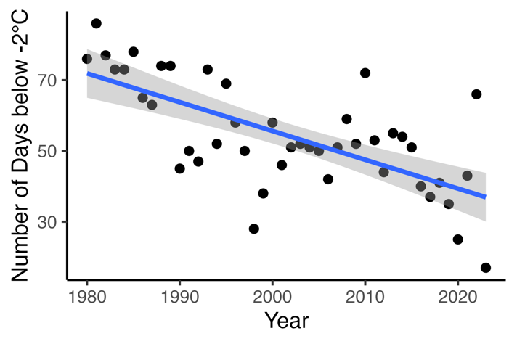

**Figure 1.** The number of days below -2°C by year between 1980 and 2023 at Clarksville, Tennessee, USA.

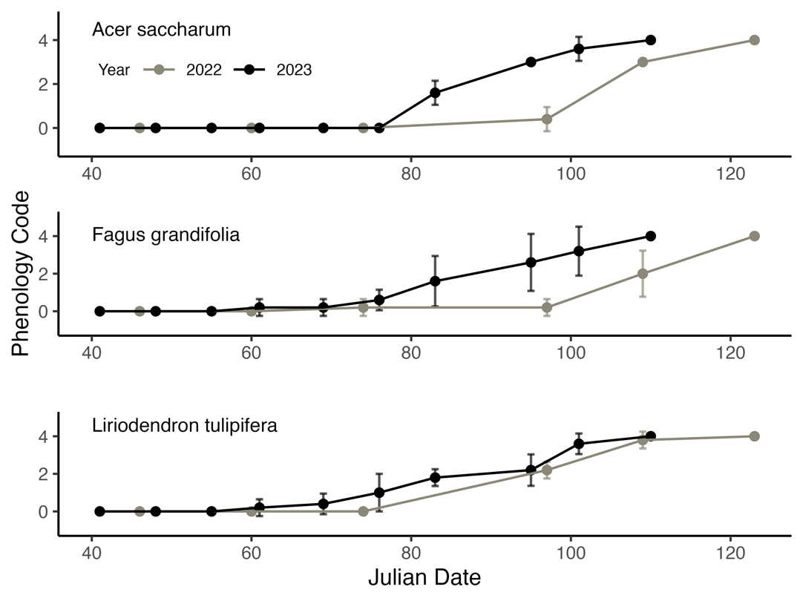

**Figure 2.** Phenology of *Acer saccharum* (top), *Fagus grandifolia* (middle), and *Liriodendron* *tulipifera* (bottom) from February to May 2022 (black) and February to May 2023 (grey) at Clarksville, Tennessee, USA, with zero indicating no bud activity, one indicating bud swelling, two indicating bud burst, three indicating initial, immature leaf formation, and four indicating full leaf development.

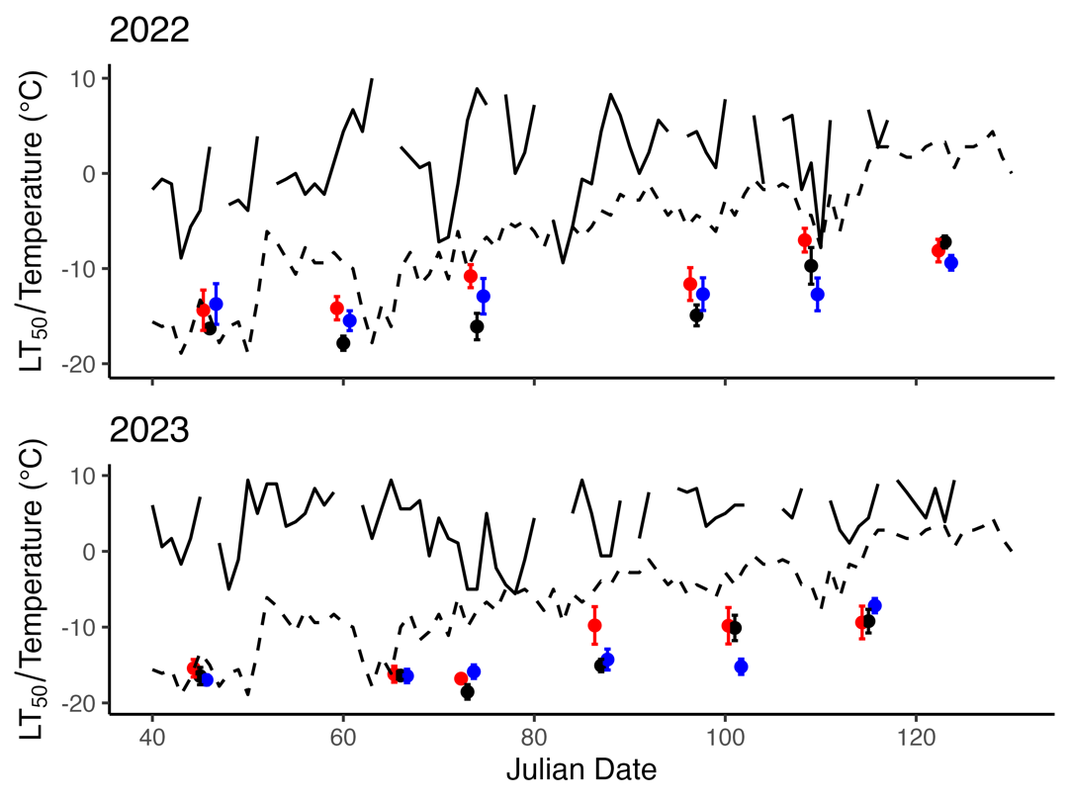

**Figure 3.** Historic absolute low temperatures since 1980 (dashed line) and low temperatures (solid line) in 2022 (top panel) and 2023 (bottom panel) with freezing tolerances (mean LT50 values in °C ± standard error) by Julian date for three native tree species in Clarksville, Tennessee, USA.